STAGE 1 architect

Here is the isolated architecture of the First Attack Stage (The Kernel Exploit via CVE-2016-5195).
This diagram breaks down exactly how the container boundary is shattered using the Dirty COW race condition at the kernel's memory management layer.
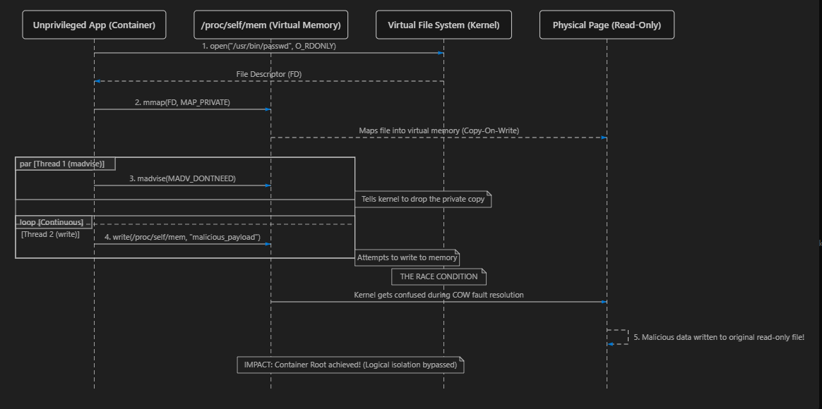

The Architectural Breakdown (Stage 1)
- Shared Kernel Vulnerability: Containers are not Virtual Machines. They do not have their own kernel; they share the host's Linux kernel.
- The Setup: The attacker inside the container opens a read-only system file (like /usr/bin/passwd) and maps it into their virtual memory using mmap() with a "private" flag. Normally, if they try to write to this memory, the kernel creates a safe, temporary copy (Copy-On-Write).
- The Race (The Exploit):
  - Thread 1 constantly yells at the kernel using madvise(), saying "throw away my temporary copy!"
  - Thread 2 constantly tries to write to the memory via /proc/self/mem.
- The Breakout: Because of the CVE-2016-5195 bug in the kernel's fault-handling logic, if the timing is perfect, the kernel gets confused. It attempts to write the data, realizes the temporary copy was thrown away by Thread 1, and accidentally writes the malicious payload directly to the physical, read-only file on the disk.
- The Result: The attacker just overwrote a critical system file, instantly gaining root privileges inside the container environment.
Stage 1 Mitigation architect
Here is the isolated Mitigation Architecture for the First Attack (Neutralizing the Dirty COW Kernel Exploit).
This diagram demonstrates how deploying a surgical Seccomp (Secure Computing) eBPF profile stands as a brick wall between the unprivileged container and the shared host kernel.
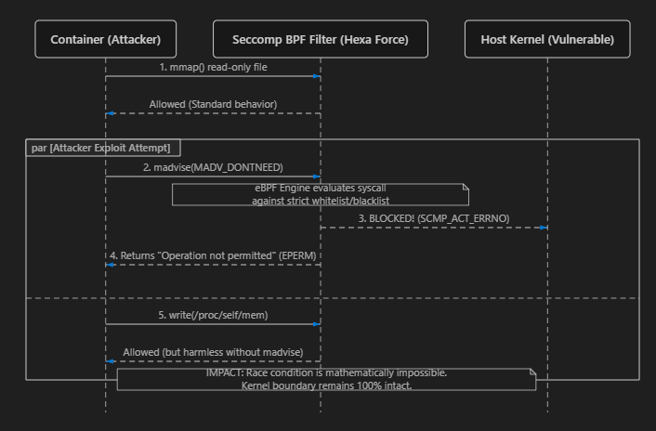

The Architectural Breakdown (Mitigation Stage 1)
- The Interception Layer: In the original attack, the container talked directly to the Host Kernel. In the Hexa Force architecture, we inject a Seccomp (Secure Computing mode) filter directly into the kernel's eBPF (Extended Berkeley Packet Filter) engine. This filter acts as a high-speed firewall for system calls.
- The Evaluation: When the attacker's script attempts to rapidly call madvise(MADV_DONTNEED) to trigger the race condition, the request doesn't go to the kernel's memory manager. It hits the Seccomp filter first.
- The Block (SCMP_ACT_ERRNO): Our custom Seccomp profile explicitly flags the madvise system call as dangerous for this specific container workload. The filter drops the request before the vulnerable kernel code ever sees it.
- The Rejection: The filter instantly returns an EPERM (Operation Not Permitted) error back to the attacker's process.
- The Result: Because madvise is blocked, the attacker's parallel write() threads just harmlessly overwrite their own temporary, private memory. The race condition cannot occur, the physical read-only file remains safe, and the container boundary is successfully defended.
Stage 2

Here is the isolated architecture of the Second Attack Stage (Process Injection via Namespace Bypass).
This diagram explains exactly how an attacker escapes the container boundary by leaping into a host-level process using the shared PID namespace and the CAP_SYS_PTRACE capability.
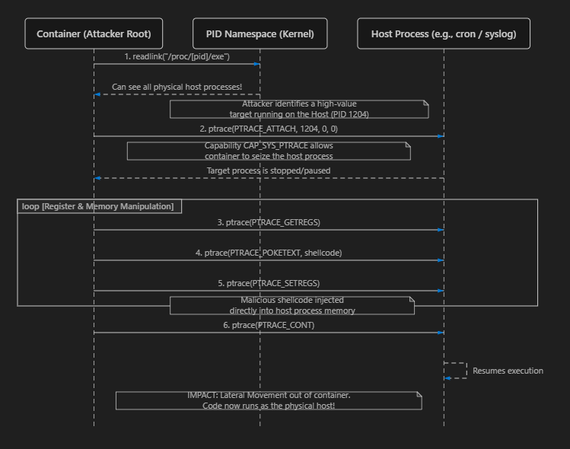

The Architectural Breakdown (Stage 2)
- The Shared Namespace Flaw: By default, if a container isn't isolated using a strict PID namespace (or if it's run with --pid=host), the attacker inside the container can "see" every single process running on the underlying bare-metal server, even though they are inside the container.
- The Target Selection: The attacker (who is now root inside the container from Stage 1) scans the /proc directory and finds a juicy target running on the host, like an orchestration agent, syslog, or cron.
- The Ptrace Attack: The attacker uses ptrace (a debugging system call allowed by the CAP_SYS_PTRACE capability) to forcefully attach to the host process. This literally stops the host process in its tracks.
- Memory Injection: Because ptrace grants full control over the target's memory and CPU registers, the attacker overwrites the host process's memory space with their own malicious shellcode.
- The Breakout: The attacker detaches and tells the host process to continue running (PTRACE_CONT). The host process unknowingly executes the attacker's shellcode.
- The Result: The attacker has successfully escaped the container. Their code is now running natively on the underlying physical infrastructure, outside of the Docker/Kubernetes boundaries.
STage 2 Mitigation plan
Here is the isolated Mitigation Architecture for the Second Attack (Neutralizing Lateral Movement and Process Injection).
This diagram demonstrates how enforcing the Principle of Least Privilege (specifically through Linux Capability dropping) physically prevents the container from hijacking host processes, even if the attacker has gained root inside the container.

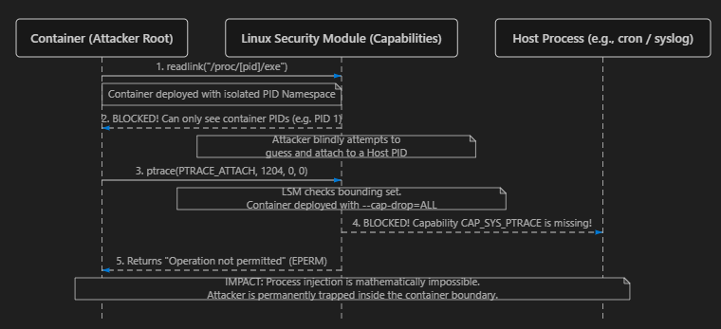

The Architectural Breakdown (Mitigation Stage 2)
- PID Namespace Isolation: In the vulnerable attack, the container was run with --pid=host, meaning it shared the host's process tree. In the mitigated architecture, we rely on Docker's default strict PID namespace. When the attacker tries to scan /proc to find a host process to hijack, they only see their own isolated container processes (PID 1). Host processes are completely invisible.
- Capability Dropping: By default, Linux grants the root user dozens of powerful capabilities. In our mitigated Hexa Force architecture, we explicitly strip these away using --cap-drop=ALL (or specifically dropping CAP_SYS_PTRACE).
- The Interception: The attacker, acting as root inside the container, attempts to call ptrace() to attach to a process and inject memory.
- The Block (EPERM): The Linux Security Module (LSM) intercepts the ptrace() call. It checks the container's capability bounding set. It sees that CAP_SYS_PTRACE is missing. The LSM instantly kills the system call before it ever touches the target process.
- The Result: Even though the attacker is technically a "root" user inside the container, they are a neutered root. They lack the kernel-level cryptographic capabilities required to debug or inject code into other processes. The lateral movement is severed.
docker run --cap-drop=ALL -it vulnerable_image /bin/bash

Stage 3
Here is the isolated architecture of the Third Attack Stage (Docker Daemon API Hijacking).
This diagram explains how an attacker seizes total administrative control over the host's container orchestration by abusing a misconfigured socket mount.

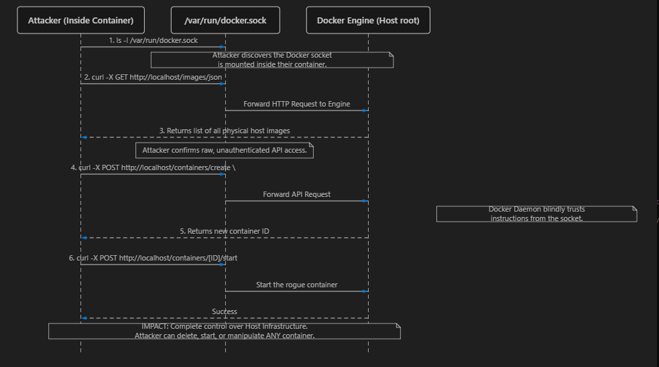

The Architectural Breakdown (Stage 3)
- The Infrastructure Flaw: For convenience (often for CI/CD pipelines or monitoring tools), DevOps engineers sometimes mount the host's Docker socket (/var/run/docker.sock) into a container. This socket is the literal control plane for the entire Docker daemon.
- The Discovery: The attacker, having broken into the container, realizes this socket file exists locally.
- The Unauthenticated API: The Docker socket is a Unix domain socket that speaks plain HTTP. It has no authentication. Anyone who can write to this file can give commands directly to the Docker engine running as root on the host.
- The API Hijack: Using a simple tool like curl, the attacker sends a JSON payload to the socket, commanding the host's Docker engine to download images, delete existing production containers, or create new rogue ones.
- The Result: The Docker engine blindly obeys. The attacker now possesses "God-mode" over the entire node. They aren't just controlling their own container anymore; they are orchestrating the entire bare-metal server's container ecosystem.
Stage 3 mitigation architecture

Here is the isolated Mitigation Architecture for the Third Attack (Neutralizing Docker Daemon API Hijacking).
This diagram demonstrates how strict Socket Isolation and Role-Based Access Control (RBAC) physically prevent the attacker from communicating with the host's orchestration engine.
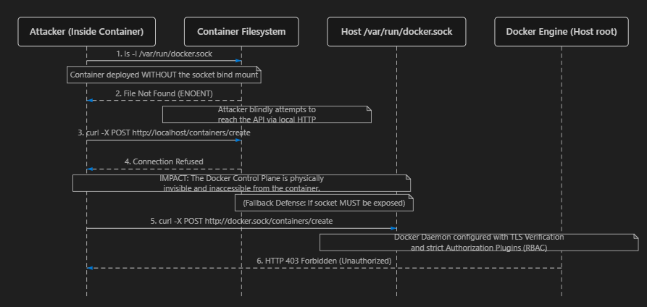

The Architectural Breakdown (Mitigation Stage 3)
- Air-Gapping the Control Plane (Socket Isolation): The absolute best mitigation for this attack is structural. In the mitigated Hexa Force architecture, we strictly forbid mounting the host's /var/run/docker.sock file into the container.
- Physical Invisibility: When the attacker tries to locate the socket file inside the container, they receive a "File Not Found" error. Because they are trapped in their own isolated Mount Namespace, they cannot see or reach the host's /var/run directory.
- Connection Refusal: Without the socket file, the attacker's curl commands have nowhere to route. The attempt to send an HTTP POST request to the Docker API simply results in a "Connection Refused." The entire Docker engine is invisible to them.
- Fallback Defense (TLS & RBAC): In rare cases where a container must have access to the Docker API (like a Jenkins CI/CD runner), the mitigation architecture shifts to Authentication and Authorization.
  - Instead of a raw Unix socket, Docker is configured to listen over a TCP port secured by Mutual TLS (mTLS).
  - The container must present a valid cryptographic client certificate.
  - Even if the attacker finds the API endpoint, they do not possess the private keys to authenticate, resulting in a strict 403 Forbidden from the daemon.

How you implement this in your lab:
To mitigate this attack, you simply ensure that the -v /var/run/docker.sock:/var/run/docker.sock flag is NEVER used when launching untrusted or web-facing containers. By omitting this single line of configuration, the control plane remains fully isolated on the bare-metal host.

Stage 4
Here is the isolated architecture of the Fourth Attack Stage (Persistent Host Takeover via Filesystem Pivot).
This diagram explains the final, fatal blow: how the attacker uses their hijacked API access to mount the physical host's hard drive and plant a permanent backdoor.
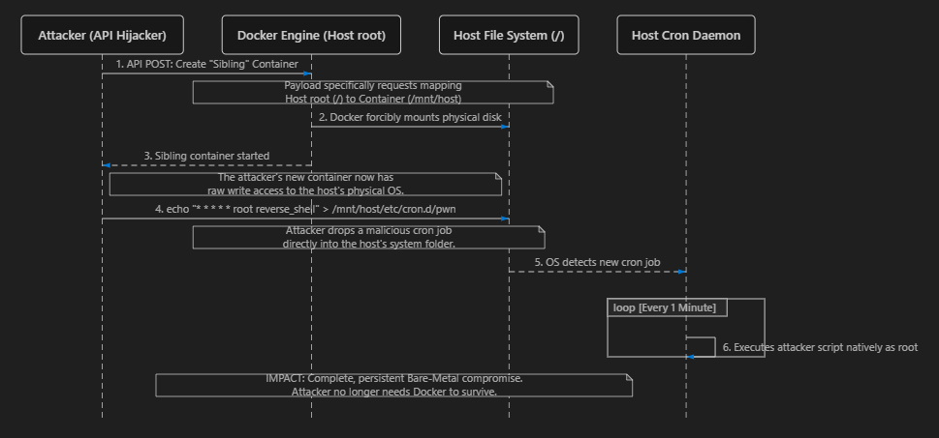

The Architectural Breakdown (Stage 4)
- The Sibling Container: Using the API control seized in Stage 3, the attacker doesn't try to attack the host directly yet. Instead, they command Docker to spawn a brand new, highly privileged "sibling" container next to their original one.
- The Mount Pivot (The Exploit): When creating this sibling container, the attacker includes a malicious bind mount configuration: -v /:/mnt/host. This tells Docker to take the entire physical hard drive of the host machine (/) and attach it inside the new container.
- Bypassing Protections: Because the Docker daemon runs as root on the host, it happily bypasses standard Linux file permissions and mounts the disk. The attacker now has full read/write access to the host's C: drive (or Linux / root) from the safety of their container.
- The Persistence Mechanism: The attacker navigates to /mnt/host/etc/cron.d/ (which is actually the physical host's system cron folder) and drops a simple text file containing a reverse shell script.
- The Final Takeover: The underlying Linux host's Cron daemon wakes up, sees a new task in its folder, and blindly executes it as root.
- The Result: The attacker now has a permanent, persistent backdoor running natively on the bare-metal server. Even if the DevOps team deletes all the containers and reinstalls Docker, the attacker will maintain control of the physical server infrastructure.
Stage 4 mitigation

Here is the isolated Mitigation Architecture for the Fourth Attack (Neutralizing Persistent Host Takeover and Filesystem Pivoting).
This diagram demonstrates how enforcing Immutable Mounts and strict Filesystem Read-Only policies prevents the attacker from dropping a permanent backdoor onto the host infrastructure, even if they somehow managed to mount the drive.
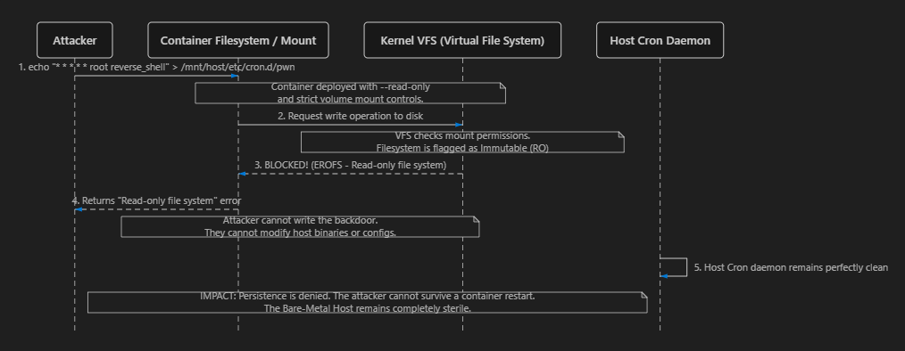

The Architectural Breakdown (Mitigation Stage 4)
- The Write Attempt: In the original attack, the attacker leveraged their API access to mount the host's physical hard drive, and then wrote a malicious script into the host's cron directory to establish permanent control.
- The Immutable Enclosure: In the mitigated Hexa Force architecture, containers are treated as ephemeral, disposable entities. We deploy them with the strict --read-only flag. This tells the kernel's Virtual File System (VFS) that nothing inside the container's environment is allowed to be modified.
- The Block (EROFS): When the attacker's echo command attempts to write the reverse shell payload to the disk, the VFS intercepts the write operation. It sees the Read-Only flag and instantly terminates the action at the lowest kernel level.
- The Rejection: The attacker's shell returns a fatal Read-only file system error. The malicious file is never created.
- The Result: The host's cron directory remains completely pristine. Because the attacker cannot write to the disk, they cannot establish persistence, modify configuration files, or drop malware binaries. If the security team detects the breach and simply restarts the container, the attacker is instantly wiped out, leaving no trace behind.

How you implement this in your lab:
To mitigate this in your architecture, you simply launch production workloads with the read-only flag, forcing any required temporary writes (like logs) into strictly controlled, isolated volumes:
bash
docker run --read-only --tmpfs /tmp -it vulnerable_image /bin/bash

